FutureQuest

[Page 1]
Your information
Full Name (text format)
University year (1st, 2nd, 3rd, final, others) → multiple choice format
Major (text format)
Mail (text format)
Phone Number (text format)
CV (optional) (link drive)

[Page 2]
Step into a world of discovery, where your strengths and interests become clues to your future. This assessment is your guide, helping you uncover who you are and explore career paths where you can thrive. Your journey starts here.

[Page 3]
You prefer work that is:
- Fast & results-driven
- Deep & analytical
- Structured & organized
- People-focused

[Page 4]
When facing a problem, you:
- Act fast
- Analyze it
- Make a plan
- Discuss with people

[Page 5]
You dislike:
- Slow progress
- Confusion in thinking
- Chaos
- Poor communication

[Page 6]
When learning something new, you:
- Learn by doing
- Study first
- Follow steps
- Learn from others

[Page 7]
You want to be known as:
- Action-oriented
- Smart problem-solver
- Reliable & structured
- Good with people

[Ending Scenario 1]
⚡ Driver (Mostly A)
Fast • Action • Results
You thrive in fast environments where speed and results matter more than overthinking.
You are most suitable for:
- Sales / Business Development
- Startup / Founder track
- Project / Delivery roles
- Account Executive
- Growth / Performance roles

[Ending Scenario 2]
🧠 Thinker (Mostly B)
Logic • Depth • Insight
You enjoy solving complex problems and understanding how systems really work.
You are most suitable for:
- Management Consulting
- Data Analyst / Business Analyst
- Product Strategy
- Research roles
- Finance / Investment Analyst

[Ending Scenario 3]
🏗 Operator (Mostly C)
Structure • Order • Execution
You make sure things actually get done smoothly, reliably, and on time.
You are most suitable for:
- Project Manager
- Operations / BizOps
- HR / Admin / People Ops
- Supply Chain / Logistics
- Program Coordinator

[Ending Scenario 4]
🤝 Connector (Mostly D)
People • Trust • Communication
You work best through people - building trust, alignment, and relationships.
You are most suitable for:
- HR / Recruiting
- Marketing / Branding
- Client Success / Account Management
- Community / Partnership roles
- PR / Communications

[Ending after completion]
Thank you for completing your journey to discover yourself. ✨
Screenshot your result, collect your gift at the booth, and stay connected with Arches for what comes next.
- LinkedIn: https://www.linkedin.com/company/arches-expert-network-service/
- Mail: recruitment@arches-global.com

[Illustration for reference]
Arches logo & pictures
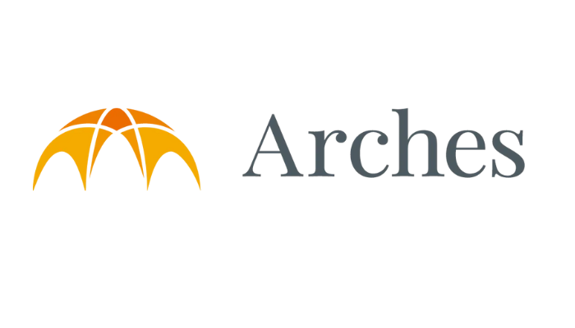
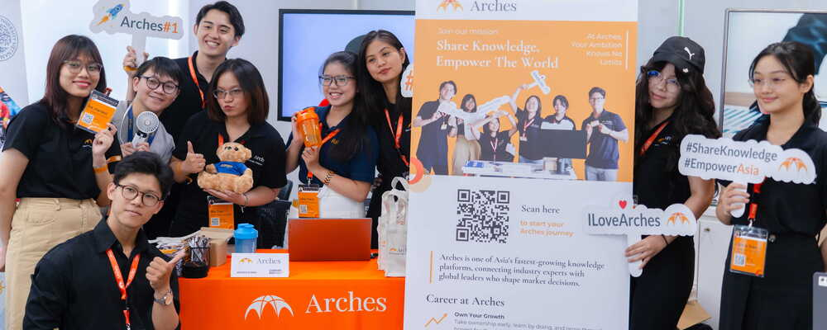

4 personalities icons
⚡🧠 🏗 🤝

